**Research Paper:**

**“ENVIRONMENTAL POLLUTION AS RESULTS OF INADEQUATE SOLID WASTE MANAGEMENT IN BIG CITIES IN CAMEROON’’**

*Presented By Afanji Smith N.*

*Strategia Institute-Netherlands-*

*Course: Water Hygiene and Sanitation*

*February, 2019.*

**List of Abbreviations Full Meaning**

HYSACAM Hygiènne et Salubrité du Cameroun

MSWM Municipal Solid Waste Management

SWM Solid Waste Management

UNCHS United Nations Conference on Human Settlement

UNEP United Nations Environment Program

W.H.O World Health Organization

**Table of Content**

**CHAPTER ONE……………………………………………………………….….Page 4**

Abstract……………………………………………………………………………..Page 4

Background…………………………………………………....................................Page 4

**CHAPTER TWO………………………………………………………………….Page 7**

Research Objective………………………………………………………………….Page 7

Research Question………………………………………………………………..…Page 7

Research methodology……………………………………………………………....Page 7

Significance of study ……………………………………………………………......Page 8

**CHAPTER THREE………………………………………………………………...Page 8**

**Literature Review………………………………………………………..………....**Page 8

**CHAPTER FOUR………………………………………………………….……….Page 11**

**Discussion**……………………………………. …………………………..………….Page 11

**CHAPTER FIVE…………………………………………………………………….PAGE 15**

Conclusion………………………………………………………………………….…Page 15

**References…………………………………………………………………………….Page 16**

**CHAPTER ONE**

**ABSTRACT**

Towns and cities in Cameroon exhibit the burdens of waste management which characterize so many African cities. Waste poses a threat to public health and the environment if it is not stored, collected, and disposed of properly. The perception of waste as an unwanted material with no intrinsic value has dominated attitudes towards disposal. Waste disposal is a major problem face in cities in the Cameroon. The Cameroon government has not been able to successfully establish a mechanism or a system of waste management that will effectively prevent environmental pollution hence reducing the public health hazard it may cause. Results indicate that solid waste management services are rudimentary; essentially collect and dump policy

Indiscriminate disposal of solid waste in dumpsites located within cities has proved to be a problem to nearby residents in most developing cities of the world. Open dumps have environmental safeguards; they can pose major public health threats and environmental effects in urban cities. Therefore, this paper presents the findings of a research carried out to determine the environmental and health impacts of solid waste disposal in city dumpsite on the surrounding human settlements in Cameroon.

**BACKGROUND**

Globally, millions of tons of municipal solid waste are generated every day. Urban waste management is drawing increasing attention, as it can easily be observed that too much garbage is lying uncollected in the streets, causing inconvenience, environmental pollution, and posing a public health risk.

The problem of solid, liquid, and toxic-waste management in Africa has come with urbanization in the developing world. An important feature of the urbanization of the developing world is the rapid growth of cities and metropolitan areas. The high rate of urbanization in African countries implies a rapid accumulation of refuse. Social and economic changes that most African countries have witnessed since the 1960s have also contributed to an increase in the waste generated per capita. As a result, municipal waste management constitutes one of the most crucial health and environmental issues facing managers of African cities. Proper waste management is a public benefit and obligation. Improper waste disposal by one individual affects the entire citizenry, so, as a policy, countries have tasked every individual, establishment or institution to contribute significantly to the process of keeping their communities and environment clean

Rapid urban development facing developing countries including Cameroon has come with serious environmental challenges concerning solid waste management. Solid waste arising from domestic, social and industrial activities is increasing in quantity and variety as a result of growing population, rising standards of living in most African countries and the development of technology (Dickerson, 1999). Solid waste management (SWM) is a common term that encompasses a wide variety of activities and practices that describes unwanted residues of any  
given culture.

Human activities generate waste which can be harmful to the environment, animals, plants and  
the ecosystem. However, only a careful management can limit the damage done to the environment and conserve scarce resources (Powell, 2001).

Waste generation dates back to man’s origin and the early way of life which principally was foraging through the nomadic experience and pattern of life. The abandonment of the nomadic way of life led to the creation of permanent communities. With mutations and evolutions that have accompanied humanity, waste that was earlier given low priority in most communities increasingly gained attention for proper management. Recently, and through communal and municipal actions, conferences and training workshops as well as government action waste  
management has become a conjecture for responsible public health and safety (Pichtel, 2005).  
The fundamental environmental issue in industrial and developing countries throughout the world over waste is the identification and management of waste streams (Twardowska, 2004). As urbanization continues to take place, the management of solid waste becomes a major challenge posing major public health and environmental problems for many countries. As a result, development must be sustainable, in the sense of reducing the ecological footprint while simultaneously improving the quality of life – for ours and future generations – within the capacity limits of the globe (Lundström, 2007).

The characteristics and quantity of Municipal Solid Waste Management (MSW) arising from domestic, commercial, and industrial activities is not only the result of growing population, rising standards of living and technological development, but also due to the abundance and type of the natural resources from the country or community (Dongqing et. al, 2010).

According to Pearce, (1994) developing countries face several major problems as a result of solid waste management and has been classifies thus:  
- Health hazards from uncollected waste  
- Health hazards from collected but poorly disposed of waste  
- Economic burden of waste disposal on towns and cities.  
According to Flintoff, (1984), the total population of developing countries accounts for more than 70 % of the world's population. Waste management in these countries is of grave concern from two points of view: Firstly, the process of urbanization and population concentration that is inextricably linked to waste management issues is progressing at a pace that is much faster than was ever experienced by today's industrialized countries. The issue of waste management in developing countries, therefore, has emerged as a critical and impending disaster. Secondly,  
these countries often have difficulty in streamlining the institutional systems, administrative bodies, management capabilities and human resources that are needed to take the lead in solving waste problems. It is thus difficult for them to respond effectively to the emerging challenges of solid waste management.  
In Cameroon, like other African countries, waste management is poorly practiced. The study of Manga et al, (2007) indicated that solid waste management services are rudimentary. The practice is primarily concerned with the collection and dumping of waste without proper management methods. This form of management is due to factors such as inadequate financial resources, low levels of law enforcement as well as poor governance lack of human resource and illiteracy. The balance between the specific components of this system in delivering sustainable waste management are already well understood and established in most developed countries, unlike in developing countries like Cameroon. Waste management could be efficient through the involvement of all stakeholders that is, waste generators, waste processors, formal and informal sectors, financial institutions and private initiatives such as non-governmental and community based organizations (Manga et al, 2007).

HYSACAM is the acronym of the French appellation of our company - 'Hygiènne et Salubrité du Cameroun', which was created in 1969 and has been in partnership with City Councils to collect and dispose of household waste in cameroon. Its activities can be regrouped into three: sensitization in a move to create awareness and provoke a change of the mentality of the population, collection and removal of household waste which calls for the creation of waste collection points and routine emptying of waste containers in homes and quarters, sweeping of streets and markets; and the transportation and processing of waste at discharge sites.

**CHAPTER TWO**

**Research Objective:**

The objective of this paper is to examine how the poor disposal and the poor management of waste by the population and the hygiene and sanitation company can create environmental pollution and a nuisance to the health of the population in cities in Cameroon.

**Research Question:**

* What are the effects of poor solid waste disposal in big cities in Cameroon?
* What is the government doing to handle the issue of waste disposal in big cities in Cameroon?
* What is the role of the population in the management of solid waste to prevent environmental pollution?  
  These questions will be answered in the course of this research paper.

**Research Methodology**

This work is largely conceptual in nature; it does not draw heavily upon empirical data. However, throughout the text, references are made, for illustrative purposes. Analysis will be done using the qualitative method of research and analysis.

Qualitative research is a method of inquiry used in many educational studies to analyses unstructured information, traditionally, it has been used in the social sciences, but it is used today by many different academic disciplines. Qualitative researchers aim to gather an in-depth understanding of human behavior and the reasons that govern such behavior. The qualitative method investigates the „why‟ and „how‟ of decision making; especially within the health domain, not just what, where, when, Hence, smaller but focused samples are more often needed, rather than large samples. This research method can and does involve a number of different approaches to measurement, words and phrases such as: a lot, a little, many most are sometime very important; as it helps to avoid specificity (Jennie Popay and Gareth Williams, 1998).

**Significance of this Study:**

The study aims to bring out the impact of poor waste management in cities in Cameroon on the environment and the importance of effective refusal disposal and waste bins and waste control to the health of the population. It will also be significant for the population to know the strategies of proper waste control and how to manage and preserve the environment for the good health of the people.

**CHAPTER THREE**

**Literature Review and Theoretical Framework**

A lot has been said, written, and demonstrated about the inadequacies in solid waste management and its associated problems. According to a United Nations Conference on Human Settlement report, one third to one-half of solid waste generated within most cities in low- and middle-income countries, of which Ghana is no exception, are not collected. They usually end up as illegal dumps on streets, open spaces, and wastelands (UNCHS 1996).

Despite the importance of adequate solid waste management to the urban environment, the performance of many city authorities in this respect leaves much to be desired. Irregular services rendered to producers of refuse by municipal councils compel them to find ways of disposing of refuse. He observed that the main methods adopted by the producers are burning, composting, or indiscriminate dumping (Malombe, 1993).

Pulverization and grinding are means of reducing the volume of waste, or they are used to prepare refuse for final disposal processes (Stirrup, 1965). He further stressed that in some instances a threefold problem could be overcome by the use of composting. Thus, the feeding of impoverished soils, disposal of large portions of the refuse, and the disposal of sewage sludge can be realised through composting. Moreover, Stirrup claimed that the major advantage of incineration are complete destruction of combustible and organic matter, reduction of bulk, the ability to operate under hygienic conditions free from interference by the type of weather conditions that would affect disposal by tipping and the possibility of using residual heat from the furnaces.

considering the fact that there are not always enough resources and infrastructure for waste management, especially in developing countries, this scenario ultimately implies that some waste will not be collected, or will be improperly disposed of (UNEP 2002). As a result, landfills, burning waste, rodents and odours, which are very common in developing countries, have made residential areas susceptible to health hazards (UNEP, 2007).

the management of household refuse is tied to perceptions and socio-cultural practices which result in modes of appropriation of space which are greatly differenced according to whether the space is private or public (Navez,B.1993). This is relevant to the study, because the area has diverse socio-cultural practices, as the population is heterogeneous.

**Definition of Terms**

**Waste**: UNEP defined wastes as substances or objects, which are disposed of, are intended to be disposed of, or are required to be disposed of by the provisions of national law. Waste also refers to “an item, material or substance you as an individual consider useless at a given time and place” (Mugambwa, 2009:1). Waste is a dynamic concept, which can be defined in different ways (Pongrácz, 2009:93). Pongrácz introduces an innovative description of waste in what she refers to as “object-oriented modeling language, PSSP. PSSP stands for purpose, structure, state and performance, which are object attributes” (Pongrácz, 2009:93). In most cases, the definition of waste depends on the type or category of waste under consideration. Some of the dominant types of waste include; municipal waste, solid waste, hazardous waste and, electronic waste. I will define municipal and solid waste, which are relevant to this study.  
**Recycling:**

*Recycling* involves the reuse of materials that are potential waste but are rather turned into valuable resources. The most important advantage with recycling is that it reduces the production of greenhouse gases since there is diversion of the waste from the landfills. Recycling also reduces the use of new resources, in a way contributing to sustainable development. Materials like paper, glass, steel, plastic, and aluminium can be recycled such that instead of disposing them of, they can be regained and thereby reused.  
**Landfilling:**

*Land filling*- this presents a safer alternative to uncontrolled dumping of solid waste. It is very clear that poor waste disposal can be dangerous to human life as well as the environment; therefore establishment of designated places (landfills) where waste that can neither be recycled nor composted can be managed, becomes necessary. A standard landfill is designed in a way that it can protect ground water from contamination, and also avoids fires that would break out as a result of methane emission.  
**Pollution:**

It is an unconcerned and uncontrolled contamination of limited natural resources available for safe survival of living beings including humans. Its untoward effects are detrimental for the healthy survival and also the contamination in most cases is not completely reversible.

**Environmental Pollution:**

Itisdefined as the presence in the environment of an agent which is potentially damaging to either the environment or human health. As such, pollutants take many forms.

**Air pollution**: The contamination of air with dangerous gases like carbon monoxide, carbon dioxide, sulfur dioxide, methane and other harmful gases due to emission from automobiles (powered by petroleum), industries and sometimes by natural calamities like volcanoes. Another type is particulate air pollution, seems quite unaware to many but if you stay near any industry, you will notice that there is always some sort of particulate dust from the chimneys of the factory. This is harmful especially to the respiratory system.

**Water pollution**:

Contamination of both drinking water from rivers, ponds and also sea water by discharge of large amounts of human, industrial wastes leads to water pollution. This makes the water harmful to drink, endanger lives of sea animals etc.

**Land pollution**:

Land pollution is one where there is excess dumping. This can be a chemical or waste material. Polluting the land by harmful chemicals can lead to entry of pollutants into food chain. This is commonly caused by excess use of fertilizers in agriculture, irresponsible disposable of industrial wastes etc. Even defecating in the open spaces also causes pollution. This leads to health issues like malnutrition as pollutants pass through plants to humans and animals.

**CHAPTER FOUR**

**DISCUSSION**

This chapter takes into consideration personal views and views of other scholars.

**The link between Pollution and Health**

The link between pollution and health is both a complex and contingent process. For pollutants to have an effect on health, susceptible individuals must receive doses of the pollutant, or its decomposition products, sufficient to trigger detectable symptoms. For this to occur, these individuals must have been exposed to the pollutant, often over relatively long periods of time or on repeated occasions. Such exposures require that the susceptible individuals and pollutants shared the same environments at the same time. For this to happen, the pollutants must not only be released into the environment, but then be dispersed through it in media used by, or accessible to, humans. Health consequences of environmental pollution are thus far from inevitable, even for pollutants that are inherently toxic; they depend on the coincidence of both the emission and dispersion processes that determine where and when the pollutant occurs in the environment, and the human behaviours that determine where and when they occupy those same locations.

**Environmental Pollution and it’s extend in Cameroon cities**

The greatest problem of environmental pollution in Cameroon cities is the problem of poor waste disposal both by the households and the hygiene and sanitation company in charge. The importance of proper solid waste management for the health of the individual and the community cannot be overemphasized. The components of solid waste management are: storage in generating premises, collection, transportation and final disposal. Proper and sanitary storage of solid waste in the premises where they are generated constitute a very important link in the chain of activities for efficient solid waste management. The most satisfactory method of collection is to provide or require each householder to provide a covered bin or other receptacle into which household refuse is placed. Public places, including parks, churches, shops, markets, motor parks etc. must have containers for solid waste storage.

Households have challenge in managing their waste in cities due to the unavailability of space, infrastructures. Houses are being constructed in these cities without provision for a proper space to preserve waste for subsequent collection by structures in charge. Individuals throw peelings of oranges, bananas and other waste on the roads after eating. Today it is common to see household members throw their waste in small bushes beside the house or unused lands. Households go as far as depositing these wastes and defecate in streams around the neighborhood.

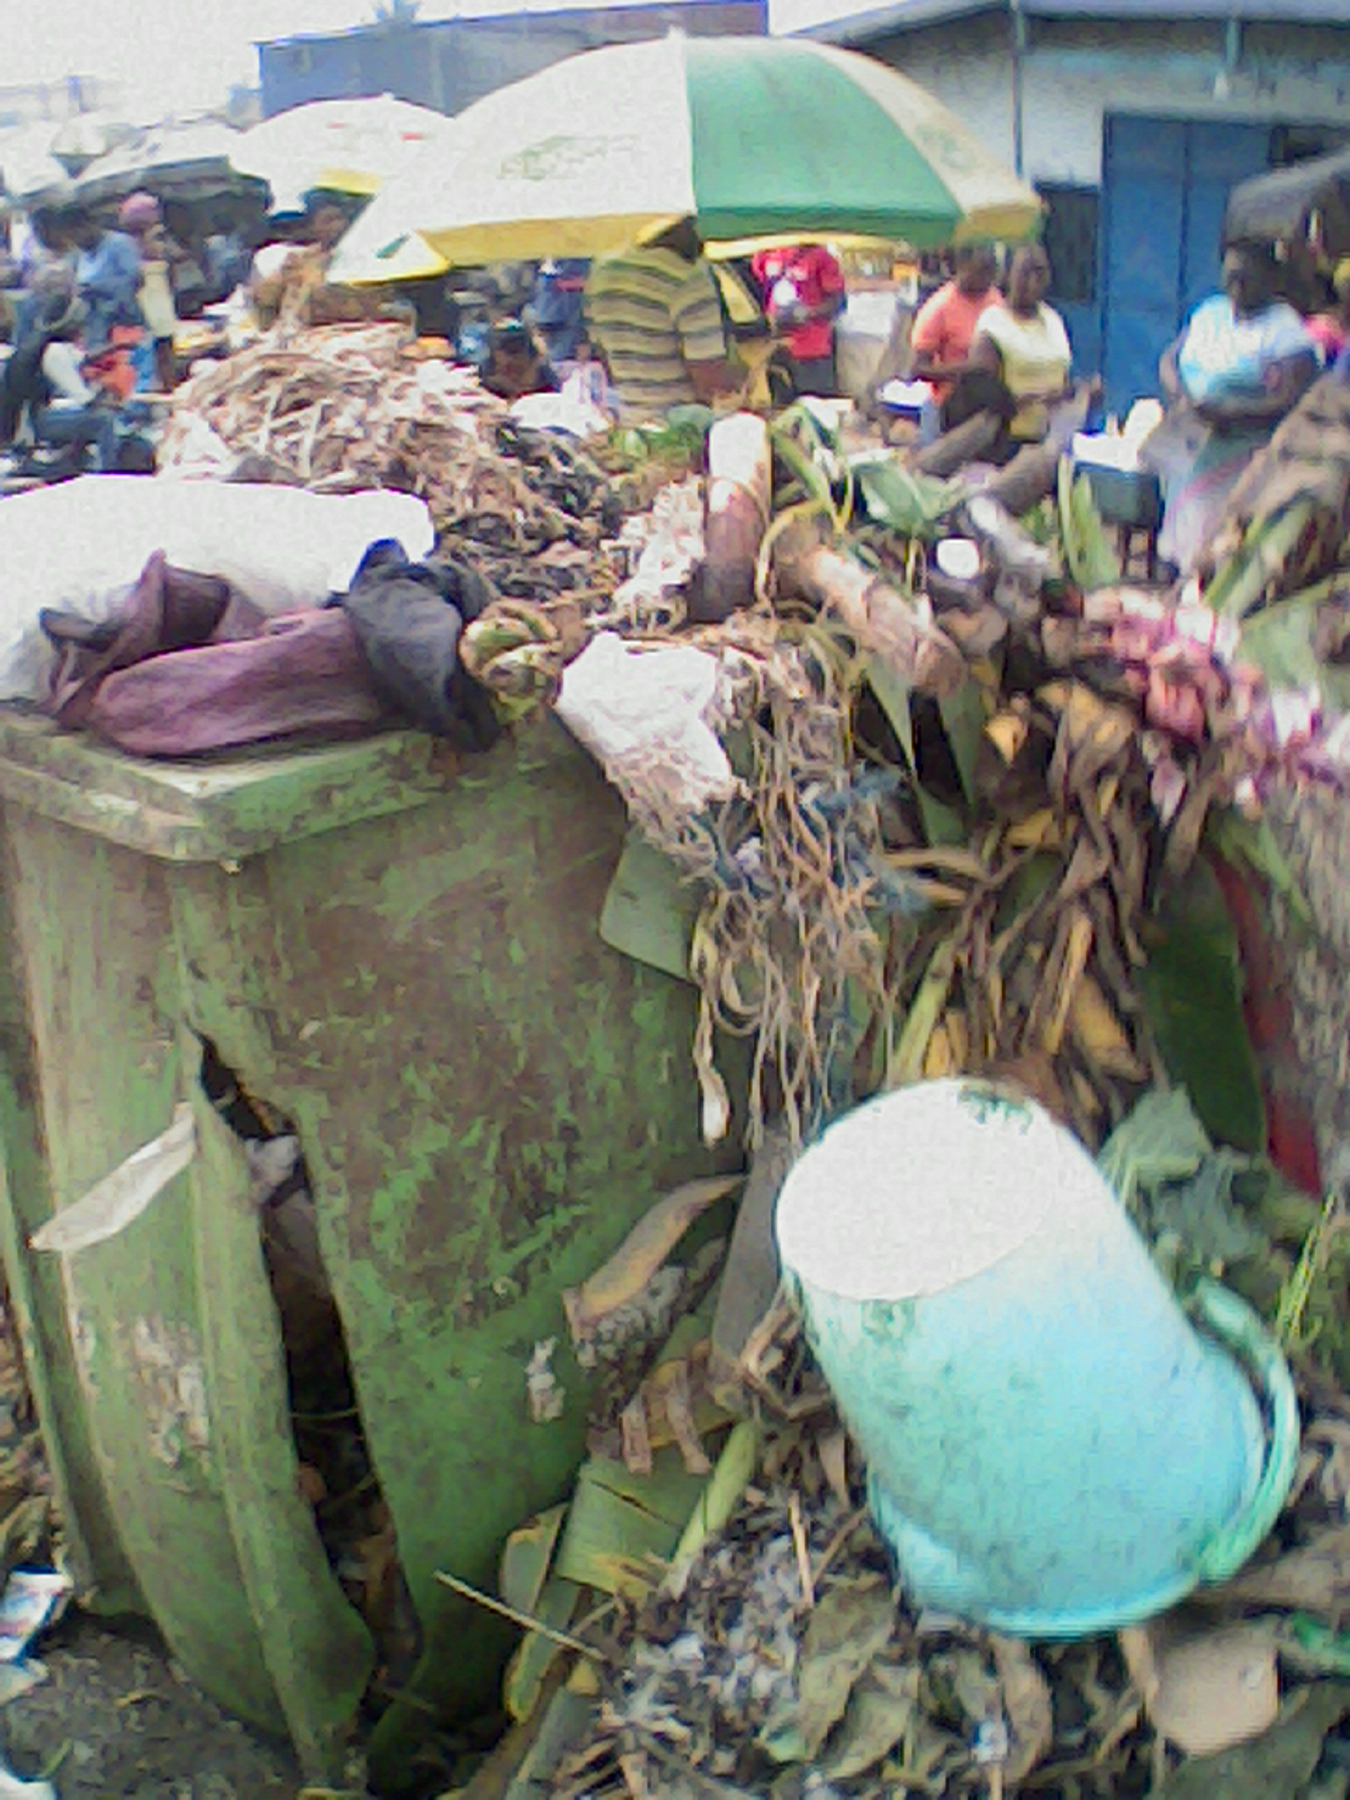

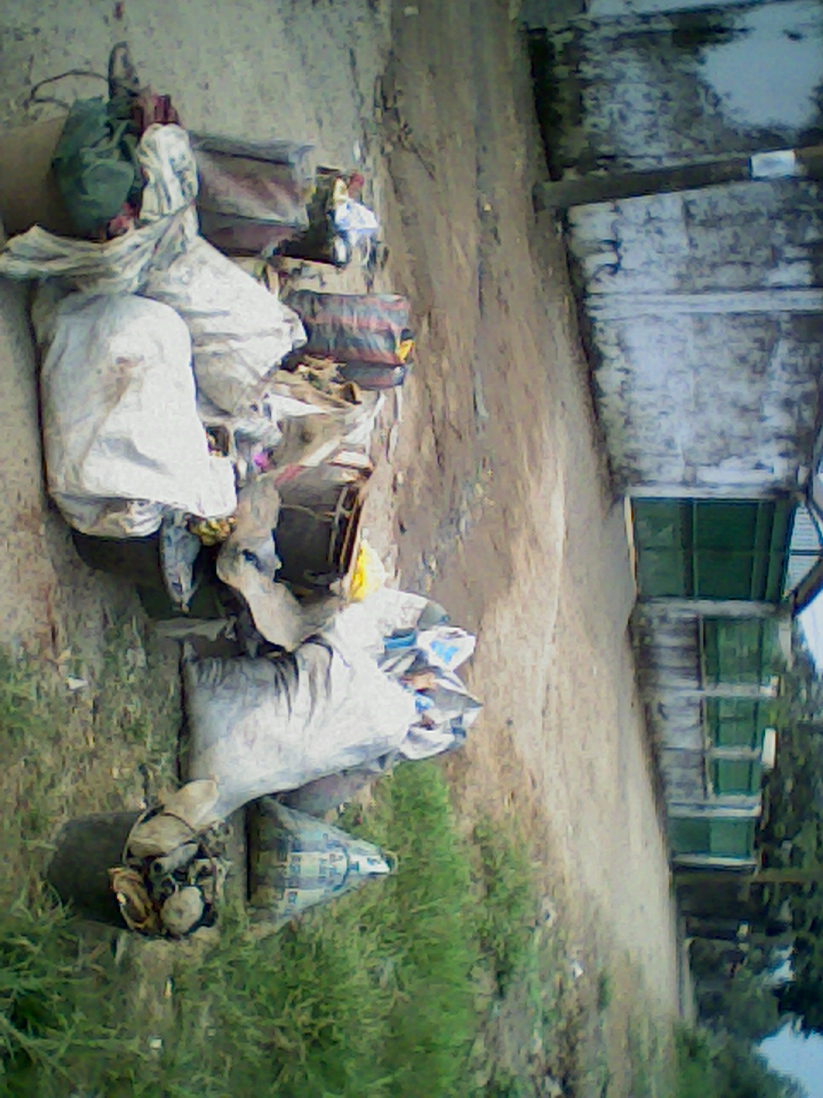

Household Waste deposited on street roads and in market space

The way Companies manage their waste is not different from the way household does. Companies don’t have a proper waste management plan; hence deposits their wastes on the streets; just it obtains in the disposal of household waste by the population or even mix up their waste with that of the household in the same bin.

The Hygiene and sanitation company (HYSACAM) contracted by the councils to manage these wastes in cities is not different from the households and industries. The method in which these solid wastes are collected and disposed is archaic and not environmental friendly. Waste collections bins are placed in public spaces without lids on it and in addition to this. These wastes are not being separated base on the characteristics. These wastes are being deposited in bushes along the roads.

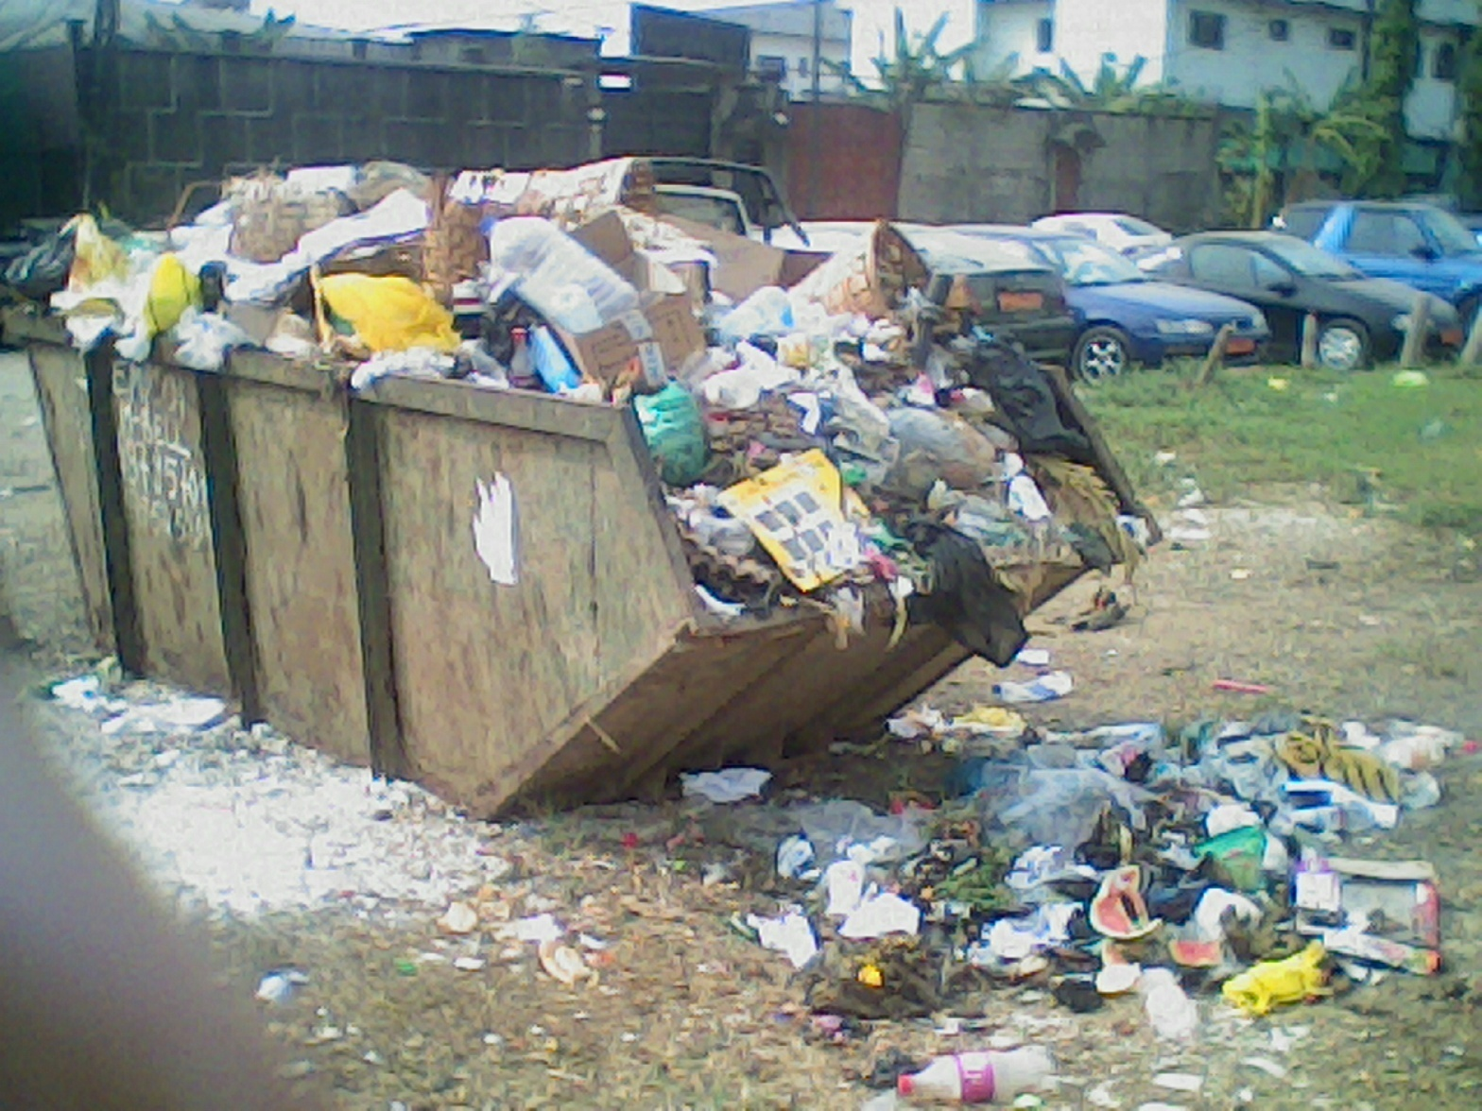

**Bins provided by hygiene and Sanitation Company to households in Douala without lid**

This company doesn’t respect the norms of waste management. Depositing waste collected from household in open air. Sometimes these wastes are being deposited beside water and when the land in which this garbage is being deposited is full, they end up burning it in open air which makes it so dangerous to the health of the population.

Looking at the ways in which these wastes are being managed tells us clearly that it is a public health problem and it detrimental to the health of the population.

**EFFECTS OF THIS POOR WASTE MANAGEMENT**

There is no doubt that the practice of poor waste disposal has an impact on the health of the population.we shall take a look at the prevalence of some diseases related to poor waste disposal in a big city like Douala in Nylon Health district;

In the majority of the households, habitants were victims of Cholera (88.5%), Diarrhoea (70 %), Dysenteries (74%), Typhoid fever (72%), Malaria (32%) and skin diseases (76%). In Madagascar, diarrhoeas (29%), Amoebic dysenteries (42%) and skin diseases (19%) were far from present. It was the same for malaria in Bonaloka (1%) and Soboum (2%). Populations contract these diseases at a frequency lower or equal to 2 years. Most of households announce the presence of mosquitoes (91%) in their quarter and were protected to 71% with mosquito nets (mechanical fight) (Table 4). A small proportion of inhabitants practice chemical fight (insecticidal) (30%). This proportion was greater in Newtown-Airport (53%) (Ndjama, J. et al 2008).

**GOVERNMENT EFFORT**

Several laws have been adopted to regulate waste generation and manage waste in Cameroon. One of these laws is Law No 96/12 of 5th August 1996 relating to Environmental management. This is the framework law on environmental management in Cameroon. According to this law, “waste” shall be any residue from a production, processing or utilization process, any substance or material produced or, more generally, any movable and immovable goods abandoned or intended to be abandoned. Under the 1996 law, waste shall be treated in an ecologically rational manner to eliminate or curb their harmful effects on human health, natural resources, the fauna and flora, and on the quality of the environment in general (Chapter VI, Section 1, Article 42). The 1996 law imposes a duty decentralized territorial councils to eliminate household waste, eliminate of all midnight dumping, eliminate of abandoned dumps with the assistance of the competent State service or authorized enterprises, when the owner or author of the dump is not known or identified.(Article 46 (1)). Article 48. (1) of the 1996 law, also provides that where waste is abandoned, dumped or processed in violation of the prescriptions of this law and its enabling regulations, the authority vested with police powers shall automatically eliminate the said waste at the expense of the said producer, after charging the producer to pay.

**CHAPTER FIVE**

**Conclusion**

Pollution is a life killer, but also a life saver. It is true that Pollution has made some disastrous effects. Pollution is becoming closer to put life on the verge of death. It has killed many lives already.

Much is being done to control, monitor and rectify damage done by pollutants. The problems are diverse and some are only being recognized but it is important to keep a close control over pollutants so that we can maintain the environment in an acceptable condition for future generations.   
We need to take pollution issue seriously because ignorance is certainly not the proper way to go. The stakes are really high and world needs to wake up and start acting right now because environmental issues are constantly growing in both number and size.

It is impossible that all the existing pollution problems in the environmental can completely be resolved in the next decade. Continuous planning, governmental policies, efforts of the enterprises and public participation must achieve a wonderful and quality environment. It is the responsibility of everyone to protect our environment. Let us fulfill our responsibilities in environmental protection, creating a quality ecological environment and sharing wonderful green living together.

**Reference**

### L’effort Cameroonais News Paper. (2006). *HYSACAM needs public collaboration to clean our towns*. Retrieved from: http://www.leffortcamerounais.com/2006/07/hysacam_needs_p.html

Malombe, J.M. (1993).*Sanitation and Solid Waste Disposal in Malindi, Kenya. 19th Water, Sanitation, environment and development conference preprints*, Ghana.

# Manga, V., Tening, F. & Adam, D.(2007). *Waste management in Cameroon: A new policy perspective*? Faculty of Science and Engineering, University of Brighton, Brighton, BN2 4GJ, UK.

Navez, B. F. (1993). *Cleanliness and the appropriation of space, refuse and living habits in large Moroccan towns,* People’s Mediterranean, Morocco. Retrieved from http://www.kon.org/urc/v6/george.html

Nkwenti, C. (2009).*Environmental & Law Thoughts*. Retrieved from: http://environmentallawthoughts.blogspot.com/2009/09/clean-up-campaign_5145.html

Stirrup, F. C. (1965) *Public Cleansing and Refuse Disposal*. Oxford, Percamon Press.

UNEP. (2005). *Waste Quantities and Characteristics*. Retrieved from: http:// www.unep.or.jp/Ietc/.

# Yaoda, R. et al. (2014).*Domestic waste disposal practice and perceptions of private sector waste management in urban Accra.* Retrieved from: http://www.ncbi.nlm.nih.gov/pmc/articles/PMC4226987/